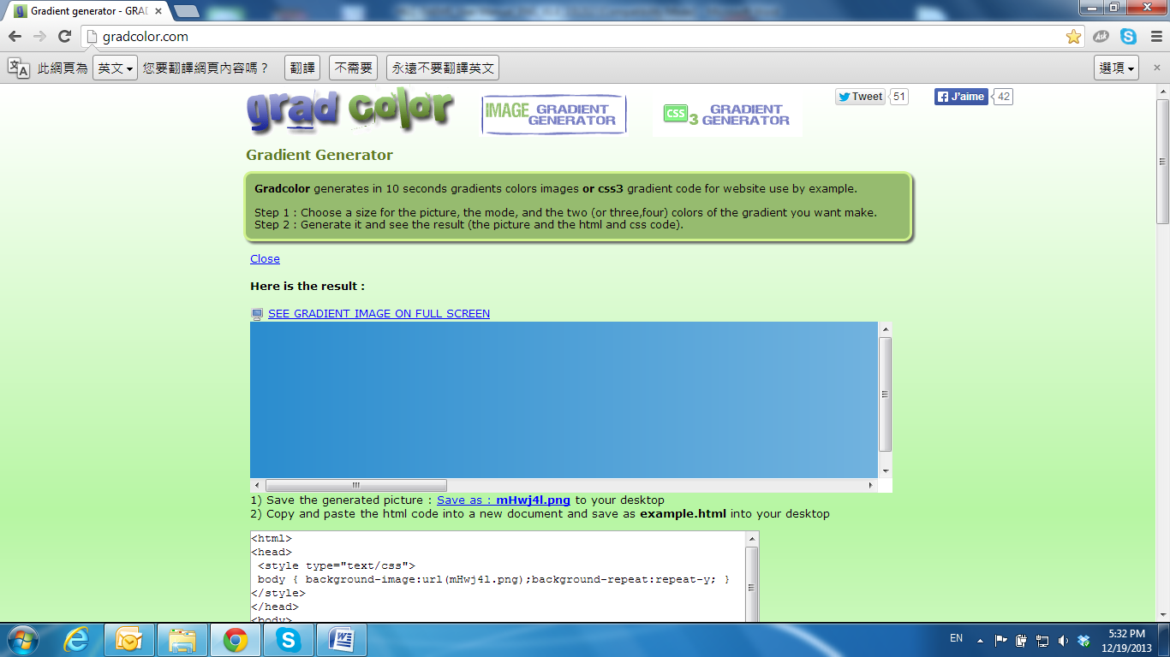

IP assignment

* + 1. Use the software **IP Installer** to assign the IP address of the IP Camera. The software is in the software CD attached to the product’s package.
    2. **IP installer** supports two languages:
       1. IPInstallerCht.exe: Chinese version
       2. IPInstallerEng.exe: English version
    3. There are 3 kinds of IP configuration.
       1. Fixed IP (Public IP or Virtual IP)
       2. DHCP (Dynamic IP)
       3. Dial-up (PPPoE)
    4. Execute **IP Installer**
    5. For Windows XP SP2 users, it may popup the following message box. Click **Unblock**.

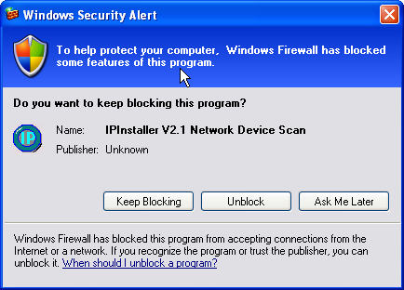

* + 1. **IP Installer** configuration:

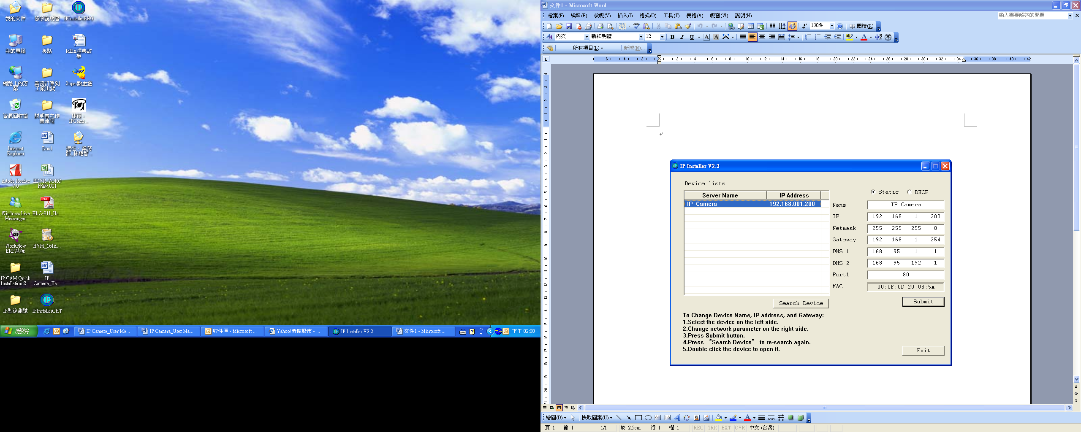

* + 1. **IP Installer** will search for all the IP Cameras connected on the LAN. The user can click **Search Device** to search again.
    2. Click one of the IP Cameras listed on the left side. The network configuration of this IP camera will be shown on the right side. You can change the **name** of the IP Camera to your preference (e.g.: Office, warehouse). Change the parameters and click **Submit**, then click **OK**, it will apply the changes and reboot the device.

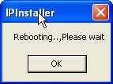

* + 1. Please make sure the subnet of the PC IP address and the IP Camera IP address are the same.

**The same Subnet:**

IP Camera IP address: 192.168.1.200

PC IP address: 192.168.1.100

**Different Subnets:**

IP Camera IP address: 192.168.2.200

PC IP address: 192.168.1.100

**To Change the PC IP address:**

Control Panel🡪Network Connections🡪Local Area Connection Properties🡪Internet Protocol (TCP/IP) 🡪Properties   
Make sure your IP Camera and PC are int the same Subnet. If not, change the IP Camera subnet or the PC IP subnet accordingly.

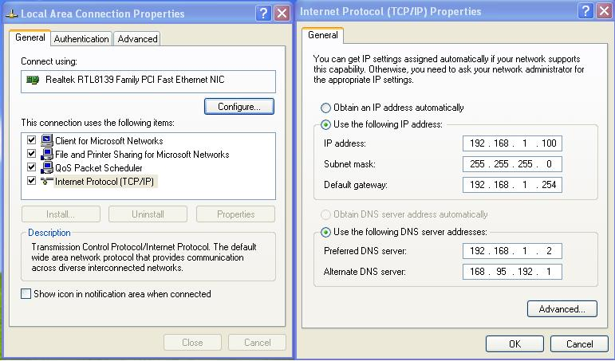

* + 1. A quick way to access remote monitoring is to left-click the mouse twice, on a selected IP Camera, listed on **Device list** of **IP Installer**. An IE browser will be opened.

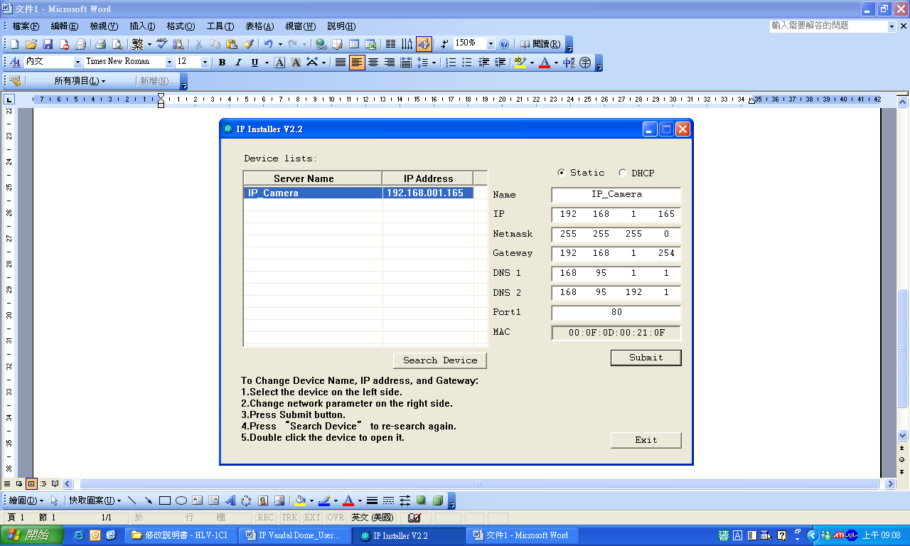

* + 1. Then, key-in the default **user name: admin** and **password: admin.**

